Phase III Trial To Evaluate The Effect Of Palofenac In Reducing Ldl Cholesterol Of Patients With Statin Treatment

Zheng Zeng

# Background

When someone has too much of a certain type of cholesterol called LDL (low-density lipoprotein), they have a higher chance of getting cardio-vascular diseases. Doctors often give patients with high LDL cholesterol a medicine called a Statin to help lower their LDL cholesterol. But sometimes, the statin isn't enough to get the cholesterol low enough, especially if the patient has other risk factors for heart disease. There are other treatments available, but they have to be given with a needle which may make it harder for some patients to take regularly. A new medicine called Palofenac has been made, which can be taken as a pill. It seems to be safe and effective based on earlier studies. This could be a better option for patients who have trouble with the other treatments. The treatment of Palofenac would most likely require at least 3 months to take effect.

This Phase III will further examine the effectiveness of Palofenac on reducing LDL cholesterol level over a period of time in patients who have high risks in getting cardio-vascular diseases and have not been able to lower their LDL cholesterol level while taking Statin for over a year.

# General trial design

## Project goal:

1. to study the effect of Palofenac reducing cholesterol level on patients with high ldl cholesterol who have been taking Statin for at least one year.
2. to study how quick and effective Palofenac is when reducing the cholesterol level of patients with high ldl cholesterol with Statin.
3. To understand the side effects of taking Palofenac while still on Statin treatment.

## Patient selection

This will be a randomized, double-blind, placebo-controlled trial conducted at a single center.

We only consider patients who have taken Statin for at least one year, but still have a LDL cholesterol level of 70 mg/dl or higher.

### Inclusion criteria

1. adults aged 18-75 years
2. high risk of cardiovascular disease, defined as having at least one of the following: history of coronary artery disease, ischemic stroke, peripheral artery disease, diabetes with additional risk factors, or 10-year cardiovascular disease risk score ≥ 20%
3. taking statins for at least one year, but with a baseline ldl cholesterol level of 70 mg/dl or higher
4. willing and able to provide written informed consent

### Exclusion criteria

1. known contraindications to Palofenac or statin
2. history of liver or kidney disease, uncontrolled hypertension, or other significant medical conditions
3. pregnant or lactating women
4. use of other lipid-lowering medications within the last 4 weeks

### Sample size

The sample size will be calculated based on the sample data from a previous study with 100 patients, who share key characteristics of our target population. The data (Table 1 in Appendix) provides the LDL cholesterol level of 100 patients at baseline, 3 months and 6 months after the treatment, which can be used in calculating the percentage reductions in LDL cholesterol level compared to baseline. We can derive the mean value and standard deviation from the data, which would later be used to estimate the sample size required for this trial, considering a dropout rate of 6%.

## Methods of randomization

We would use a cluster sampling method to randomly select patients that satisfy our requirements.

* Search through the database to find potential participants using filters on their medication history and LDL cholesterol level records.
* Contact the patients for consent to participate in the clinical trial.

## Measurement collection

We will measure patients’ LDL cholesterol level each time they visit by taking blood samples at the approximately same time of the day of visit. After we have collected all the measurements from all the visits, we would calculate the percentage change of patients’ LDL cholesterol level compared to baseline recorded on the previous visit. The primary endpoint would be the three percentage change records for each patient.

# Treatment schedules

The registration of participants would be open until the sample size of the desired patient population is reached. The duration of the trial for each patient will be at least 9 months, and measurements will be taken at the beginning, end of 3 months, 6 months and 9 months. The trial for each patient may begin at different times, based on when their next visit to their hospitals will be, and the clock will start clicking once the first visit is secured.

## Timeline

| Day 0 First Visit | * Patient information will be obtained and recorded, including demographics, medical history, concomitant medications, and any relevant laboratory values. * Informed consent will be obtained from the patient. * A physical exam will be performed, including measurements of height, weight, blood pressure, and heart rate. * Blood samples will be collected to measure baseline levels of LDL cholesterol, triglycerides, and other relevant biomarkers. * Patients will be randomly assigned to a treatment and given instructions on how to take the study drug and any relevant study procedures or assessments. * Patients will be scheduled for follow-up visits at the end of month 3 , month 8, and month 12, at which time additional measurements and assessments will be performed. |
| --- | --- |
| Day 90 Second Visit | * Patients would be asked to complete a survey on their treatment in the past 90 days for us to assess if they have taken the drug effectively. * Blood samples will be collected to measure the 90-day level of ldl cholesterol, triglycerides, and other relevant biomarkers. * Patients would be given the treatment for the next 3 months and guidance to take the drug. |
| Day 180 Third Visit | * Patients would be asked to complete a survey on their treatment in the past 90 days for us to assess if they have taken the drug effectively. * Blood samples will be collected to measure the current level of ldl cholesterol, triglycerides, and other relevant biomarkers. * Patients would be notified that it is the end of the trial and they would receive compensation or other form of appreciation after the trial ends. |

## Treatment allocation

For each selected patient, we use a random number generator to generate a unique integer number as an identifier. For patients with an even number, they would be given the study drug (Palofenac), while for patients with an odd identifier, they would be given the placebo. The conductor of the treatment would not know what number belongs to which treatment group since it is a double-blinded experiment.

# Statistical analysis methods

## Methods of analysis

### Descriptive statistics

We will use descriptive statistics to summarize the baseline characteristics, such as mean, standard deviation and its general distribution.

### Test statistic

We would use the T statistic to test the hypothesis that the addition of Palofenac to treat patients with high LDL cholesterol level and Statin treatment for over a year.

Let X be the percentage reduction in LDL cholesterol level compared to baseline after 3 months of treatment of Palofenac, and Y be the percentage reduction without the treatment of Palofenac. Let $σ_{1}$ be the standard variance for the treatment group, $σ_{2}$ be the true deviation for the control group, and $n_{1}$ the sample size for X and $n_{2}$ that for Y.

And the hypothesis is

$H_{0}: Y - X=0.2 vs H_{1}: Y - X>=0.2$

Thus the test statistics goes like

$T = (Y-X- 0.2)/\sqrt{{σ^{2}}_{1}/n_{1}+ {σ^{2}}_{2}/n_{2}}$

And we need to estimate $n_{1 } and n_{2}$. Let $n = n_{1}=n_{2}$, and X and Y share the same standard deviation $s$. We use the sample data to estimate Y and s (Appendix 2).

$σ_{1}, σ_{2} -> s/\sqrt{n} , thus T = (Y-X- 0.2)/s\sqrt{2/n} \sim T{}_{df = 100-1} , with Y = \bar{Y}=0.08, and s =0.3$.

Under the null hypothesis, to reject the null hypothesis, we have the following equation

$P(T >=0) >power -> P(T <=0) <= ( 1-power)/2$.

Since for this trial, we need to maintain a two-sided Type I error of 5% and a power of at least 90%, we would have this equation

$P(T <=0) <=0.05 ->(X-Y-0.2)/s\sqrt{2/n} <= -1.66$.

Let’s substitute X with the sample mean value from the previous study and we have

$n >= (1.66/(0.2-0.08) *0.3 * \sqrt{2})^{2 } = 34.445 ≈ 35$.

Considering the dropout rate of 6%, the final desired sample size would be

$2 * n *(1+dropout \%) = 73.001 ≈74$

Thus, the total sample size should be at least 74, with 37 in both the placebo arm and the Palofenac arm.

# Appendix

1. Table of the sample data

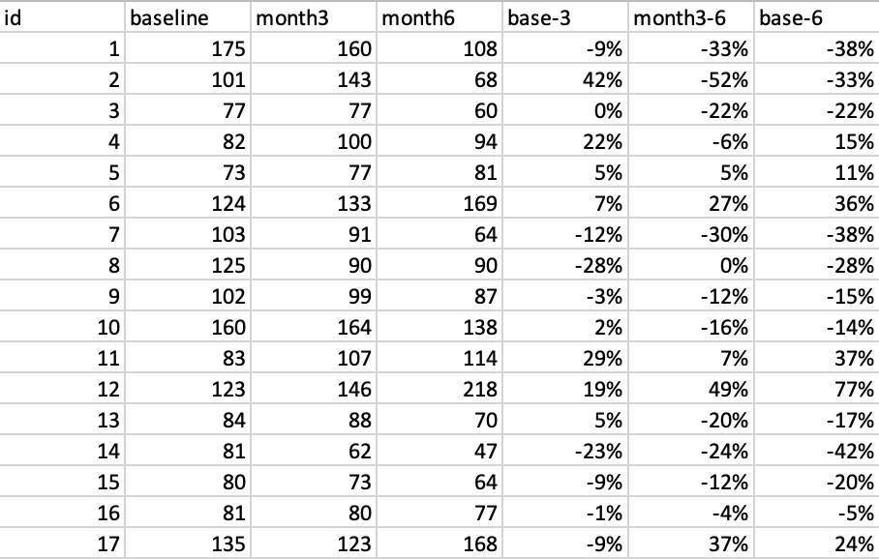

1. Sample data’s mean and standard deviation

